**TASK 3**

**A. SQL Code to define the schema described in Task 2.**

//Code starts here//

//Creation of Database Music//

CREATE DATABASE `music` /*!40100 DEFAULT CHARACTER SET utf8 */;

//Creating Table for Entity: Album//

CREATE TABLE `album` (

`albumID` int(11) NOT NULL,

`albumName` varchar(255) DEFAULT NULL,

`noOfTracks` int(11) DEFAULT NULL,

`albumType` enum('Single','Compilation','Band') DEFAULT NULL,

`albumRating` enum('1','2','3','4','5') DEFAULT NULL,

`albumduration` time DEFAULT NULL,

PRIMARY KEY (`albumID`)

) ENGINE=InnoDB DEFAULT CHARSET=utf8;

//Creating Table for Entity : AlbumCollection//

CREATE TABLE `albumcollection` (

`productID` int(11) NOT NULL,

`albumFormat` enum('CD','Vinyl') DEFAULT NULL,

`albumCondition` enum('Poor','Acceptable','Good','Very Good','Mint') DEFAULT NULL,

`recordDate` date DEFAULT NULL,

`releaseDate` date DEFAULT NULL,

`purchaseDate` date DEFAULT NULL,

`purchaseAmount` double DEFAULT NULL,

`albumID` int(11) DEFAULT NULL,

PRIMARY KEY (`productID`),

KEY `albumID` (`albumID`),

CONSTRAINT `albumcollection_ibfk_1` FOREIGN KEY (`albumID`) REFERENCES `album`

(`albumID`) ON DELETE CASCADE

) ENGINE=InnoDB DEFAULT CHARSET=utf8;

//Creating Table for Entity : Artist//

CREATE TABLE `artist` (

`artistID` int(11) NOT NULL,

`artistName` varchar(255) DEFAULT NULL,

PRIMARY KEY (`artistID`)

) ENGINE=InnoDB DEFAULT CHARSET=utf8;

//Creating Table for Entity : ArtistCollection//

CREATE TABLE `artistcollection` (

`artistID` int(11) NOT NULL DEFAULT '0',

`albumId` int(11) NOT NULL DEFAULT '0',

PRIMARY KEY (`artistID`,`albumId`),

KEY `albumId` (`albumId`),

CONSTRAINT `artistcollection_ibfk_1` FOREIGN KEY (`albumId`) REFERENCES `album`

(`albumID`) ON DELETE CASCADE,

CONSTRAINT `artistcollection_ibfk_2` FOREIGN KEY (`artistID`) REFERENCES `artist`

(`artistID`)

) ENGINE=InnoDB DEFAULT CHARSET=utf8;

//Creating Table for Entity : Band//

CREATE TABLE `band` (

`bandID` int(11) NOT NULL,

`bandName` varchar(255) DEFAULT NULL,

PRIMARY KEY (`bandID`)

) ENGINE=InnoDB DEFAULT CHARSET=utf8;

//Creating Table for Entity : BandMembers//

CREATE TABLE `bandmembers` (

`bandID` int(11) NOT NULL DEFAULT '0',

`artistID` int(11) NOT NULL DEFAULT '0',

PRIMARY KEY (`bandID`,`artistID`),

KEY `artistID` (`artistID`),

CONSTRAINT `bandmembers_ibfk_1` FOREIGN KEY (`bandID`) REFERENCES `band`

(`bandID`),

CONSTRAINT `bandmembers_ibfk_2` FOREIGN KEY (`artistID`) REFERENCES `artist`

(`artistID`)

) ENGINE=InnoDB DEFAULT CHARSET=utf8;

//Creating Table for Entity : Genre//

CREATE TABLE `genre` (

`albumID` int(11) NOT NULL DEFAULT '0',

`albumgenre` enum('Pop','Rock','Metal','Jazz','Techno','Classical','Country') NOT NULL

DEFAULT 'Pop',

PRIMARY KEY (`albumID`,`albumgenre`),

CONSTRAINT `genre_ibfk_1` FOREIGN KEY (`albumID`) REFERENCES `album` (`albumID`)

ON DELETE CASCADE

) ENGINE=InnoDB DEFAULT CHARSET=utf8;

Explanation of constraints remaining

**B. Reverse Engineering Digram and Insert Commands for every table**

**1. Reverse Engineering Diagram (EER Diagram) obtained from MySQL Workbench.**

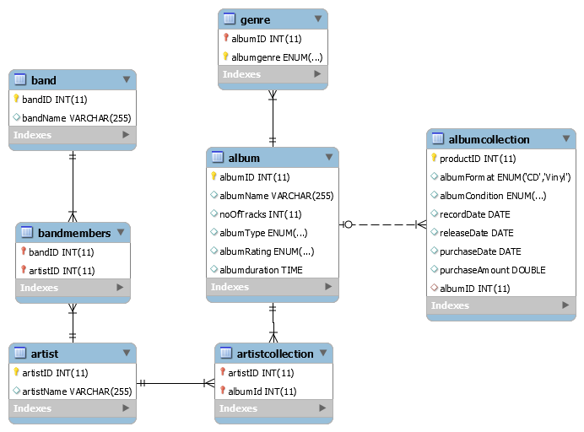

Figure: EER Diagram for Database Music Collection

1. **SQL code to populate the database with sample data**

**List of Insert Commands and the respective tables populated with data.**

a. Insert commands for Table album

INSERT INTO `album` (`albumID`,`albumName`,`noOfTracks`,`albumType`,`albumRating`,`albumduration`) VALUES (1001,'timeless',10,'Compilation','5','01:03:05');

INSERT INTO `album` (`albumID`,`albumName`,`noOfTracks`,`albumType`,`albumRating`,`albumduration`) VALUES (1002,'Never Gone',12,'Single','4','00:47:41');

INSERT INTO `album` (`albumID`,`albumName`,`noOfTracks`,`albumType`,`albumRating`,`albumduration`) VALUES (1003,'Dont Look Down',12,'Single','4','00:48:33');

INSERT INTO `album` (`albumID`,`albumName`,`noOfTracks`,`albumType`,`albumRating`,`albumduration`) VALUES (1004,'The Piano Guys',13,'Band','4','00:52:51');

INSERT INTO `album` (`albumID`,`albumName`,`noOfTracks`,`albumType`,`albumRating`,`albumduration`) VALUES (1005,'Connections',8,'Single','5','00:48:08');

INSERT INTO `album` (`albumID`,`albumName`,`noOfTracks`,`albumType`,`albumRating`,`albumduration`) VALUES (1006,'Desperado',11,'Single','4','00:35:40');

INSERT INTO `album` (`albumID`,`albumName`,`noOfTracks`,`albumType`,`albumRating`,`albumduration`) VALUES (1007,'A Love supreme',3,'Single','3','00:33:00');

INSERT INTO `album` (`albumID`,`albumName`,`noOfTracks`,`albumType`,`albumRating`,`albumduration`) VALUES (1008,'Oceans Kingdom',8,'Single','5','00:56:33');

INSERT INTO `album` (`albumID`,`albumName`,`noOfTracks`,`albumType`,`albumRating`,`albumduration`) VALUES (1009,'The Family Way',2,'Single','4','00:24:59');

INSERT INTO `album` (`albumID`,`albumName`,`noOfTracks`,`albumType`,`albumRating`,`albumduration`) VALUES (1010,'Redemption',8,'Band','5','01:08:13');

INSERT INTO `album` (`albumID`,`albumName`,`noOfTracks`,`albumType`,`albumRating`,`albumduration`) VALUES (1011,'Frankly Sentimental',8,'Compilation','3','01:10:22');

INSERT INTO `album` (`albumID`,`albumName`,`noOfTracks`,`albumType`,`albumRating`,`albumduration`) VALUES (1012,'Hamilton',23,'Compilation','5','01:52:23');

INSERT INTO `album` (`albumID`,`albumName`,`noOfTracks`,`albumType`,`albumRating`,`albumduration`) VALUES (1013,'Wide Open',12,'Single','3','00:56:44');

INSERT INTO `album` (`albumID`,`albumName`,`noOfTracks`,`albumType`,`albumRating`,`albumduration`) VALUES (1014,'Ten Thousand Fist',14,'Band','4','00:56:00');

INSERT INTO `album` (`albumID`,`albumName`,`noOfTracks`,`albumType`,`albumRating`,`albumduration`) VALUES (1015,'Sheet one',11,'Single','4','01:00:00');

INSERT INTO `album` (`albumID`,`albumName`,`noOfTracks`,`albumType`,`albumRating`,`albumduration`) VALUES (1016,'Turning Dragon',11,'Single','3','01:07:31');

INSERT INTO `album` (`albumID`,`albumName`,`noOfTracks`,`albumType`,`albumRating`,`albumduration`) VALUES (1017,'Insomniac',15,'Single','5','00:58:01');

Above Table populated with sample data:

SELECT * FROM music.album

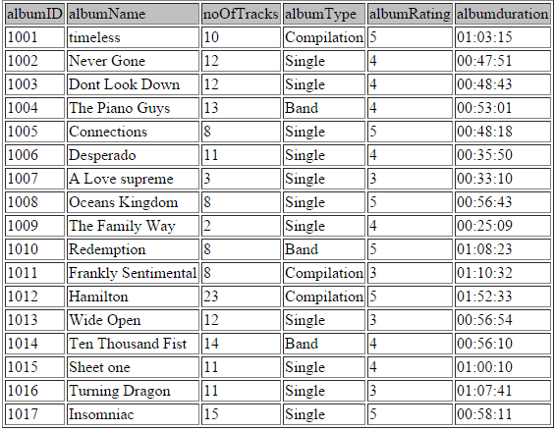

b. Insert commands for Table albumcollection

INSERT INTO `albumcollection` (`productID`,`albumFormat`,`albumCondition`,`recordDate`,`releaseDate`,`purchaseDate`,`purchaseAmount`,`albumID`) VALUES (2001,'CD','Mint','2015-02-23','2015-08-16','2015-09-17',5.99,1001);

INSERT INTO `albumcollection` (`productID`,`albumFormat`,`albumCondition`,`recordDate`,`releaseDate`,`purchaseDate`,`purchaseAmount`,`albumID`) VALUES (2002,'CD','Good','2005-01-26','2005-12-10','2007-07-21',5.99,1002);

INSERT INTO `albumcollection` (`productID`,`albumFormat`,`albumCondition`,`recordDate`,`releaseDate`,`purchaseDate`,`purchaseAmount`,`albumID`) VALUES (2003,'CD','Good','2012-12-29','2013-07-05','2014-08-23',8.82,1003);

INSERT INTO `albumcollection` (`productID`,`albumFormat`,`albumCondition`,`recordDate`,`releaseDate`,`purchaseDate`,`purchaseAmount`,`albumID`) VALUES (2004,'CD','Very Good','2011-05-06','2012-10-02','2013-06-05',9.99,1004);

INSERT INTO `albumcollection` (`productID`,`albumFormat`,`albumCondition`,`recordDate`,`releaseDate`,`purchaseDate`,`purchaseAmount`,`albumID`) VALUES (2005,'CD','Acceptable','2008-09-09','2008-10-10','2011-05-27',8.99,1005);

INSERT INTO `albumcollection` (`productID`,`albumFormat`,`albumCondition`,`recordDate`,`releaseDate`,`purchaseDate`,`purchaseAmount`,`albumID`) VALUES (2006,'Vinyl','Good','1972-10-10','1973-04-12','1980-05-13',9.9,1006);

INSERT INTO `albumcollection` (`productID`,`albumFormat`,`albumCondition`,`recordDate`,`releaseDate`,`purchaseDate`,`purchaseAmount`,`albumID`) VALUES (2007,'Vinyl','Very Good','1962-12-30','1965-02-22','1970-05-24',11.62,1007);

INSERT INTO `albumcollection` (`productID`,`albumFormat`,`albumCondition`,`recordDate`,`releaseDate`,`purchaseDate`,`purchaseAmount`,`albumID`) VALUES (2008,'CD','Good','2011-06-25','2011-10-03','2014-05-02',14.79,1008);

INSERT INTO `albumcollection` (`productID`,`albumFormat`,`albumCondition`,`recordDate`,`releaseDate`,`purchaseDate`,`purchaseAmount`,`albumID`) VALUES (2009,'Vinyl','Good','1966-11-23','1967-06-12','1999-10-03',2.53,1009);

INSERT INTO `albumcollection` (`productID`,`albumFormat`,`albumCondition`,`recordDate`,`releaseDate`,`purchaseDate`,`purchaseAmount`,`albumID`) VALUES (2010,'CD','Poor','2002-10-05','2003-03-18','2006-05-12',1.99,1010);

INSERT INTO `albumcollection` (`productID`,`albumFormat`,`albumCondition`,`recordDate`,`releaseDate`,`purchaseDate`,`purchaseAmount`,`albumID`) VALUES (2011,'Vinyl','Acceptable','1946-08-21','1949-06-20','1995-03-21',0.99,1011);

INSERT INTO `albumcollection` (`productID`,`albumFormat`,`albumCondition`,`recordDate`,`releaseDate`,`purchaseDate`,`purchaseAmount`,`albumID`) VALUES (2012,'CD','Mint','2015-07-24','2015-09-25','2015-09-27',20.39,1012);

INSERT INTO `albumcollection` (`productID`,`albumFormat`,`albumCondition`,`recordDate`,`releaseDate`,`purchaseDate`,`purchaseAmount`,`albumID`) VALUES (2013,'CD','Good','2008-12-15','2009-04-07','2011-12-12',1.99,1013);

INSERT INTO `albumcollection` (`productID`,`albumFormat`,`albumCondition`,`recordDate`,`releaseDate`,`purchaseDate`,`purchaseAmount`,`albumID`) VALUES (2014,'CD','Poor','2005-01-15','2005-09-20','2005-10-21',0.99,1014);

INSERT INTO `albumcollection` (`productID`,`albumFormat`,`albumCondition`,`recordDate`,`releaseDate`,`purchaseDate`,`purchaseAmount`,`albumID`) VALUES (2015,'CD','Very Good','1966-11-23','2003-05-10','2006-05-12',1.99,1009);

INSERT INTO `albumcollection` (`productID`,`albumFormat`,`albumCondition`,`recordDate`,`releaseDate`,`purchaseDate`,`purchaseAmount`,`albumID`) VALUES (2016,'CD','Very Good','1966-11-23','2003-05-10','2007-05-12',1.99,1009);

INSERT INTO `albumcollection` (`productID`,`albumFormat`,`albumCondition`,`recordDate`,`releaseDate`,`purchaseDate`,`purchaseAmount`,`albumID`) VALUES (2017,'CD','Good','1966-11-23','2003-05-10','2007-05-12',1.99,1009);

INSERT INTO `albumcollection` (`productID`,`albumFormat`,`albumCondition`,`recordDate`,`releaseDate`,`purchaseDate`,`purchaseAmount`,`albumID`) VALUES (2018,'CD','Very Good','1993-07-21','1993-10-18','2003-09-21',2.5,1015);

INSERT INTO `albumcollection` (`productID`,`albumFormat`,`albumCondition`,`recordDate`,`releaseDate`,`purchaseDate`,`purchaseAmount`,`albumID`) VALUES (2019,'CD','Acceptable','2007-10-03','2008-01-28','2012-05-15',1.99,1016);

INSERT INTO `albumcollection` (`productID`,`albumFormat`,`albumCondition`,`recordDate`,`releaseDate`,`purchaseDate`,`purchaseAmount`,`albumID`) VALUES (2020,'CD','Very Good','2008-09-09','2009-05-10','2014-06-12',9.99,1005);

INSERT INTO `albumcollection` (`productID`,`albumFormat`,`albumCondition`,`recordDate`,`releaseDate`,`purchaseDate`,`purchaseAmount`,`albumID`) VALUES (2021,'CD','Mint','1972-10-10','2015-08-31','2015-09-29',6.5,1006);

INSERT INTO `albumcollection` (`productID`,`albumFormat`,`albumCondition`,`recordDate`,`releaseDate`,`purchaseDate`,`purchaseAmount`,`albumID`) VALUES (2022,'CD','Poor','2002-10-05','2003-03-18','2005-03-21',0.99,1010);

INSERT INTO `albumcollection` (`productID`,`albumFormat`,`albumCondition`,`recordDate`,`releaseDate`,`purchaseDate`,`purchaseAmount`,`albumID`) VALUES (2023,'Vinyl','Mint','1972-10-10','1973-04-12','2005-05-23',11.9,1006);

INSERT INTO `albumcollection` (`productID`,`albumFormat`,`albumCondition`,`recordDate`,`releaseDate`,`purchaseDate`,`purchaseAmount`,`albumID`) VALUES (2024,'Vinyl','Mint','1962-12-30','1965-02-22','2010-09-26',8.9,1007);

INSERT INTO `albumcollection` (`productID`,`albumFormat`,`albumCondition`,`recordDate`,`releaseDate`,`purchaseDate`,`purchaseAmount`,`albumID`) VALUES (2025,'CD','Mint','2006-12-11','2007-06-11','2009-05-21',14,1017);

INSERT INTO `albumcollection` (`productID`,`albumFormat`,`albumCondition`,`recordDate`,`releaseDate`,`purchaseDate`,`purchaseAmount`,`albumID`) VALUES (2026,'CD','Good','2006-12-11','2007-06-11','2008-09-26',10,1017);

INSERT INTO `albumcollection` (`productID`,`albumFormat`,`albumCondition`,`recordDate`,`releaseDate`,`purchaseDate`,`purchaseAmount`,`albumID`) VALUES (2027,'CD','Acceptable','2002-10-05','2011-05-08','2012-06-09',2.99,1010);

Above Table populated with sample data:

SELECT * FROM music.albumcollection

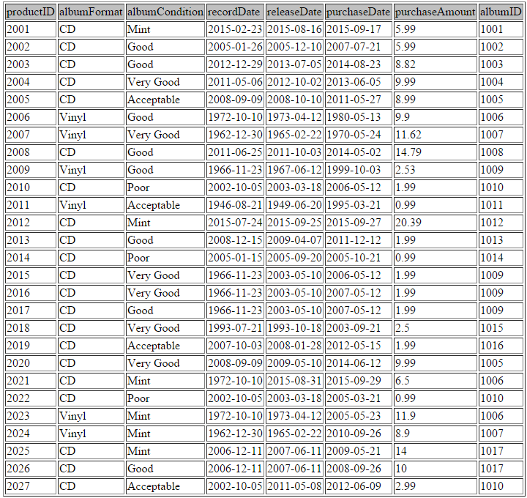

c. Insert commands for Table artist

INSERT INTO `artist` (`artistID`,`artistName`) VALUES (801,'Billy Joel');

INSERT INTO `artist` (`artistID`,`artistName`) VALUES (802,'Bruce Springsteen');

INSERT INTO `artist` (`artistID`,`artistName`) VALUES (803,'Robert Plant');

INSERT INTO `artist` (`artistID`,`artistName`) VALUES (804,'Kevin Richardson');

INSERT INTO `artist` (`artistID`,`artistName`) VALUES (805,'Brian Litrell');

INSERT INTO `artist` (`artistID`,`artistName`) VALUES (806,'Skylar Grey');

INSERT INTO `artist` (`artistID`,`artistName`) VALUES (807,'Steven Nelson');

INSERT INTO `artist` (`artistID`,`artistName`) VALUES (808,'John Schmidt');

INSERT INTO `artist` (`artistID`,`artistName`) VALUES (809,'Paul Anderson');

INSERT INTO `artist` (`artistID`,`artistName`) VALUES (810,'Sukhwinder Singh');

INSERT INTO `artist` (`artistID`,`artistName`) VALUES (811,'Shraddha Pandit');

INSERT INTO `artist` (`artistID`,`artistName`) VALUES (812,'Naresh Iyer');

INSERT INTO `artist` (`artistID`,`artistName`) VALUES (813,'Len Frey');

INSERT INTO `artist` (`artistID`,`artistName`) VALUES (814,'Don Henly');

INSERT INTO `artist` (`artistID`,`artistName`) VALUES (815,'Burney Leadon');

INSERT INTO `artist` (`artistID`,`artistName`) VALUES (816,'Randy Meisner');

INSERT INTO `artist` (`artistID`,`artistName`) VALUES (817,'John Coltrane');

INSERT INTO `artist` (`artistID`,`artistName`) VALUES (818,'Paul Mcartny');

INSERT INTO `artist` (`artistID`,`artistName`) VALUES (819,'Rick Mythiasin');

INSERT INTO `artist` (`artistID`,`artistName`) VALUES (820,'Bernie Versailles');

INSERT INTO `artist` (`artistID`,`artistName`) VALUES (821,'Nick Van Dyke');

INSERT INTO `artist` (`artistID`,`artistName`) VALUES (822,'Jason Rullo');

INSERT INTO `artist` (`artistID`,`artistName`) VALUES (823,'Frank Sinatra');

INSERT INTO `artist` (`artistID`,`artistName`) VALUES (824,'Axel Stordahl');

INSERT INTO `artist` (`artistID`,`artistName`) VALUES (825,'Lin Miranda');

INSERT INTO `artist` (`artistID`,`artistName`) VALUES (826,'Jason Aldean');

INSERT INTO `artist` (`artistID`,`artistName`) VALUES (827,'Dan Donegan');

INSERT INTO `artist` (`artistID`,`artistName`) VALUES (828,'Mike Wengren');

INSERT INTO `artist` (`artistID`,`artistName`) VALUES (829,'David Draiman');

INSERT INTO `artist` (`artistID`,`artistName`) VALUES (830,'John Moyer');

INSERT INTO `artist` (`artistID`,`artistName`) VALUES (831,'Richie Hawtin');

INSERT INTO `artist` (`artistID`,`artistName`) VALUES (832,'Chris Clark');

Above Table populated with sample data:

SELECT * FROM music.artist

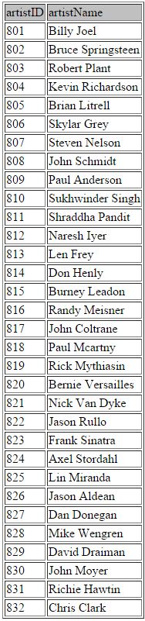

d. Insert commands for table artistcollection:

INSERT INTO `artistcollection` (`artistID`,`albumId`) VALUES (801,1001);

INSERT INTO `artistcollection` (`artistID`,`albumId`) VALUES (802,1001);

INSERT INTO `artistcollection` (`artistID`,`albumId`) VALUES (803,1001);

INSERT INTO `artistcollection` (`artistID`,`albumId`) VALUES (804,1002);

INSERT INTO `artistcollection` (`artistID`,`albumId`) VALUES (805,1002);

INSERT INTO `artistcollection` (`artistID`,`albumId`) VALUES (806,1003);

INSERT INTO `artistcollection` (`artistID`,`albumId`) VALUES (807,1004);

INSERT INTO `artistcollection` (`artistID`,`albumId`) VALUES (808,1004);

INSERT INTO `artistcollection` (`artistID`,`albumId`) VALUES (809,1004);

INSERT INTO `artistcollection` (`artistID`,`albumId`) VALUES (810,1005);

INSERT INTO `artistcollection` (`artistID`,`albumId`) VALUES (811,1005);

INSERT INTO `artistcollection` (`artistID`,`albumId`) VALUES (812,1005);

INSERT INTO `artistcollection` (`artistID`,`albumId`) VALUES (813,1006);

INSERT INTO `artistcollection` (`artistID`,`albumId`) VALUES (814,1006);

INSERT INTO `artistcollection` (`artistID`,`albumId`) VALUES (815,1006);

INSERT INTO `artistcollection` (`artistID`,`albumId`) VALUES (816,1006);

INSERT INTO `artistcollection` (`artistID`,`albumId`) VALUES (817,1007);

INSERT INTO `artistcollection` (`artistID`,`albumId`) VALUES (818,1008);

INSERT INTO `artistcollection` (`artistID`,`albumId`) VALUES (819,1009);

INSERT INTO `artistcollection` (`artistID`,`albumId`) VALUES (820,1009);

INSERT INTO `artistcollection` (`artistID`,`albumId`) VALUES (821,1009);

INSERT INTO `artistcollection` (`artistID`,`albumId`) VALUES (822,1009);

INSERT INTO `artistcollection` (`artistID`,`albumId`) VALUES (823,1010);

INSERT INTO `artistcollection` (`artistID`,`albumId`) VALUES (824,1011);

INSERT INTO `artistcollection` (`artistID`,`albumId`) VALUES (825,1012);

INSERT INTO `artistcollection` (`artistID`,`albumId`) VALUES (826,1013);

INSERT INTO `artistcollection` (`artistID`,`albumId`) VALUES (827,1014);

INSERT INTO `artistcollection` (`artistID`,`albumId`) VALUES (828,1014);

INSERT INTO `artistcollection` (`artistID`,`albumId`) VALUES (829,1014);

INSERT INTO `artistcollection` (`artistID`,`albumId`) VALUES (830,1014);

INSERT INTO `artistcollection` (`artistID`,`albumId`) VALUES (831,1015);

INSERT INTO `artistcollection` (`artistID`,`albumId`) VALUES (832,1016);

Above table populated with sample data

SELECT * FROM music.artistcollection

//Table on next Page//

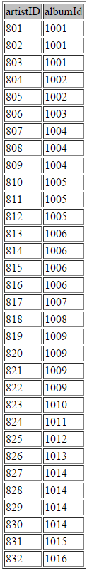

e. Insert commands for table band

INSERT INTO `band` (`bandID`,`bandName`) VALUES (901,'Led Zeppelin');

INSERT INTO `band` (`bandID`,`bandName`) VALUES (902,'Backstreet Boys');

INSERT INTO `band` (`bandID`,`bandName`) VALUES (903,'Piano Guys');

INSERT INTO `band` (`bandID`,`bandName`) VALUES (904,'Eagles');

INSERT INTO `band` (`bandID`,`bandName`) VALUES (905,'Redemption');

INSERT INTO `band` (`bandID`,`bandName`) VALUES (906,'Disturbed');

Above table populated with sample data:

SELECT * FROM music.band

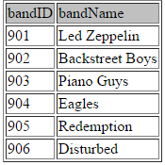

f. Insert commands for table bandmembers

INSERT INTO `bandmembers` (`bandID`,`artistID`) VALUES (901,801);

INSERT INTO `bandmembers` (`bandID`,`artistID`) VALUES (901,802);

INSERT INTO `bandmembers` (`bandID`,`artistID`) VALUES (901,803);

INSERT INTO `bandmembers` (`bandID`,`artistID`) VALUES (902,804);

INSERT INTO `bandmembers` (`bandID`,`artistID`) VALUES (902,805);

INSERT INTO `bandmembers` (`bandID`,`artistID`) VALUES (903,807);

INSERT INTO `bandmembers` (`bandID`,`artistID`) VALUES (903,808);

INSERT INTO `bandmembers` (`bandID`,`artistID`) VALUES (903,809);

INSERT INTO `bandmembers` (`bandID`,`artistID`) VALUES (904,813);

INSERT INTO `bandmembers` (`bandID`,`artistID`) VALUES (904,814);

INSERT INTO `bandmembers` (`bandID`,`artistID`) VALUES (904,815);

INSERT INTO `bandmembers` (`bandID`,`artistID`) VALUES (904,816);

INSERT INTO `bandmembers` (`bandID`,`artistID`) VALUES (905,819);

INSERT INTO `bandmembers` (`bandID`,`artistID`) VALUES (905,820);

INSERT INTO `bandmembers` (`bandID`,`artistID`) VALUES (905,821);

INSERT INTO `bandmembers` (`bandID`,`artistID`) VALUES (905,822);

INSERT INTO `bandmembers` (`bandID`,`artistID`) VALUES (906,827);

INSERT INTO `bandmembers` (`bandID`,`artistID`) VALUES (906,828);

INSERT INTO `bandmembers` (`bandID`,`artistID`) VALUES (906,829);

INSERT INTO `bandmembers` (`bandID`,`artistID`) VALUES (906,830);

Above table populated with sample data:

SELECT * FROM music.bandmembers

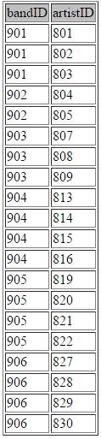

g. Insert commands for table genre:

INSERT INTO `genre` (`albumID`,`albumgenre`) VALUES (1001,'Rock');

INSERT INTO `genre` (`albumID`,`albumgenre`) VALUES (1001,'Classical');

INSERT INTO `genre` (`albumID`,`albumgenre`) VALUES (1002,'Pop');

INSERT INTO `genre` (`albumID`,`albumgenre`) VALUES (1002,'Rock');

INSERT INTO `genre` (`albumID`,`albumgenre`) VALUES (1003,'Pop');

INSERT INTO `genre` (`albumID`,`albumgenre`) VALUES (1004,'Classical');

INSERT INTO `genre` (`albumID`,`albumgenre`) VALUES (1005,'Pop');

INSERT INTO `genre` (`albumID`,`albumgenre`) VALUES (1006,'Rock');

INSERT INTO `genre` (`albumID`,`albumgenre`) VALUES (1006,'Classical');

INSERT INTO `genre` (`albumID`,`albumgenre`) VALUES (1007,'Jazz');

INSERT INTO `genre` (`albumID`,`albumgenre`) VALUES (1008,'Classical');

INSERT INTO `genre` (`albumID`,`albumgenre`) VALUES (1009,'Rock');

INSERT INTO `genre` (`albumID`,`albumgenre`) VALUES (1010,'Metal');

INSERT INTO `genre` (`albumID`,`albumgenre`) VALUES (1011,'Pop');

INSERT INTO `genre` (`albumID`,`albumgenre`) VALUES (1011,'Classical');

INSERT INTO `genre` (`albumID`,`albumgenre`) VALUES (1012,'Classical');

INSERT INTO `genre` (`albumID`,`albumgenre`) VALUES (1013,'Rock');

INSERT INTO `genre` (`albumID`,`albumgenre`) VALUES (1013,'Country');

INSERT INTO `genre` (`albumID`,`albumgenre`) VALUES (1014,'Metal');

INSERT INTO `genre` (`albumID`,`albumgenre`) VALUES (1015,'Techno');

INSERT INTO `genre` (`albumID`,`albumgenre`) VALUES (1016,'Techno');

Above table populated with sample data

SELECT * FROM music.genre

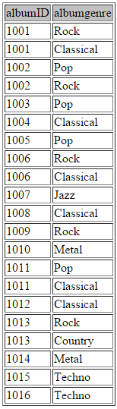

**4. Seperate list of constraints:**

ON DELETE CASCADE

albumID in albumcollection

albumID in genre

ON DELETE SET NULL

albumID in artistcollection

**C. Initial state of database.**

Initial state of the database

Explanation: